- Do not edit/delete any heading or section with red text.
- Type /paste you answers in relevant sections (below Final Answer (in all questions , Approach (wherever required ) and Charts & tables (wherever required)) of the solution
- Link to submission guidelines
- Please note that submission not following the guidelines will not be accepted

OBJECTIVE QUESTIONS

Question 1: What is the total no. of tables present in the data?

Solution:

Final Answer
- Total number of tables: 1
- Source Sheet: data
- Cleaned Dataset: Cleaned data sheet was created from the original data sheet for analysis.
Table
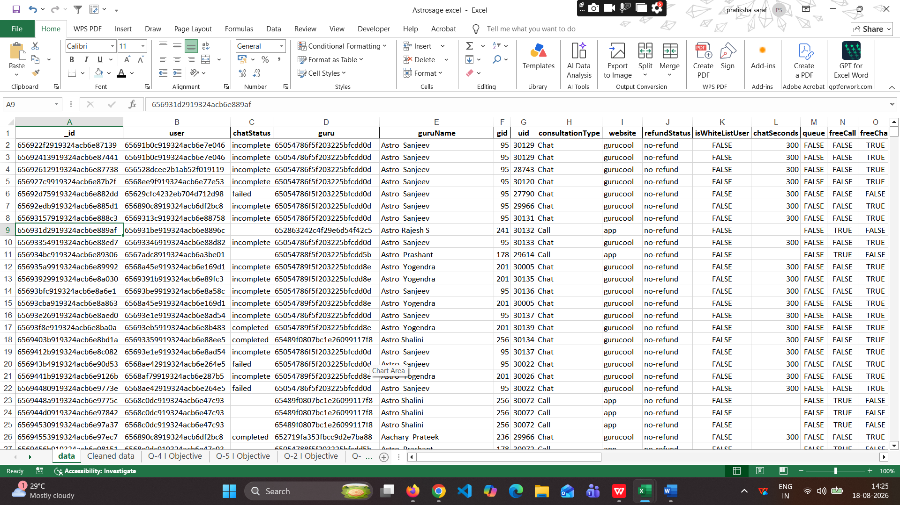

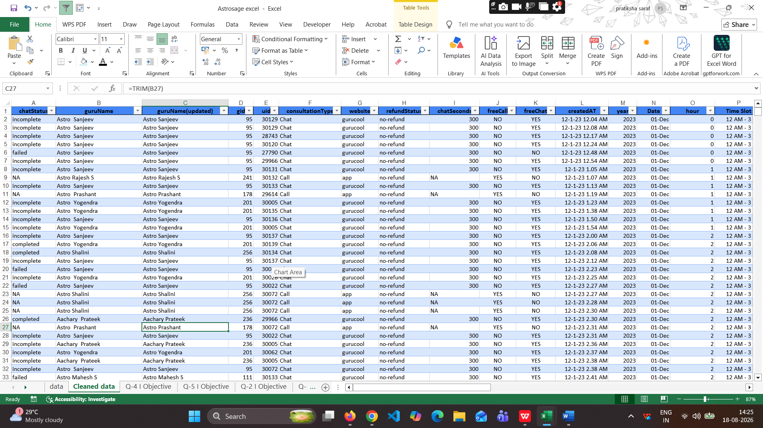

Question 2: What is the total no. of attributes present in the data?

Solution:

Final Answer (if any):
The original dataset has 35 attributes, while the cleaned dataset has 36 attributes.
Approach (if any):
Used the COUNT function to count the number of attributes in the dataset.
Charts & Tables (if any):
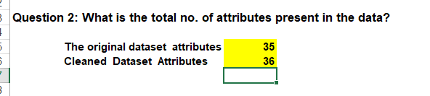

Question 3: The data consists of some inconsistent and missing values so ensure that the data used for further analysis is cleaned.

Solution:

Final Answer (if any):
The dataset was cleaned by removing duplicates, handling missing values, removing unnecessary entries, standardizing values, and converting relevant fields into the appropriate number format.

Approach (if any):
• Removed duplicate records no duplicates were found.
• Applied filters to identify inconsistent and missing values.
• Trimmed extra spaces from AstroGuru names.
• Repaced blank Chat Seconds cells with N/A where there was a call.
• Replaced blank Chat Status cells with N/A for cals and complimentary calls.
• Used Find & Replace to change FALSE as No 165,625 replacments and TRUE as Yes 6,483 replacements.
• Converted Rating, GID, UID, Chat Seconds, and Astologer Call Duration into number format.
Charts & Tables (if any): 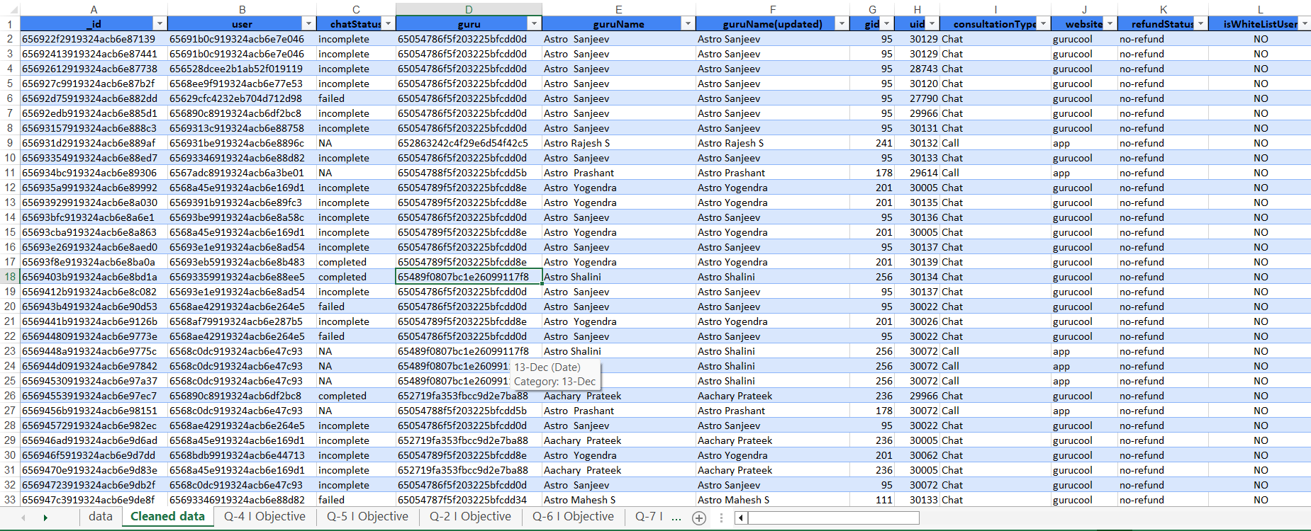

Question 4: What is the change in daily call volume day by day and also find the average daily call volume.

Solution:

Final Answer (if any):
The average daily call volume is 246 calls per day
- The highest daily call volume was 430 calls on 10-Dec, while the lowest was 107 calls on 03-Jan
Approach (if any):
- Used a Pivot Table to calculate the total number of calls for each day.
- Calculated the day-by-day change by subtracting the previous day's call volume from the current day's call volume.
- Formula is Average Daily Call Volume = Total Calls ÷ Number of Days.
- The calculated average daily call volume = 246 calls.

Charts & Tables (if any):

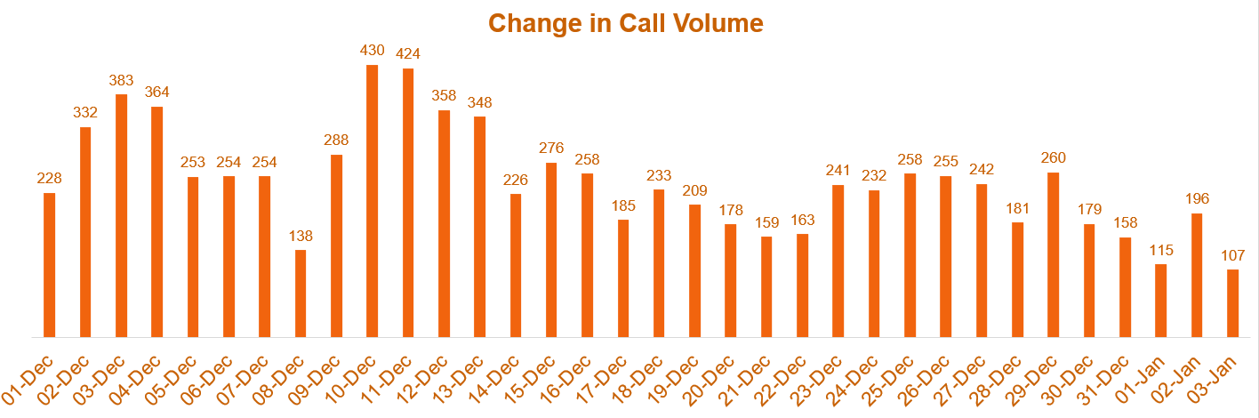
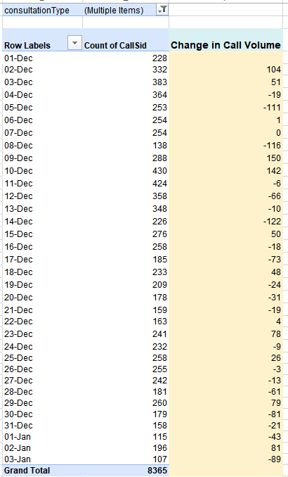
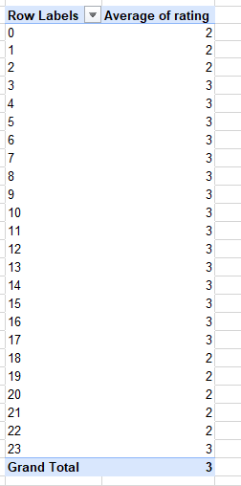

Question 5: Which months experienced the highest and lowest call volumes?

Solution:

Final Answer (if any):
December experienced the highest call volume with 7947 calls, while January experienced the lowest call volume with 418 calls.
Approach (if any):
Used a Pivot Table to calculate the total number of calls for each month and compared the monthly call volumes to identify the highest and lowest values.
Charts & Tables (if any):
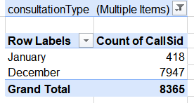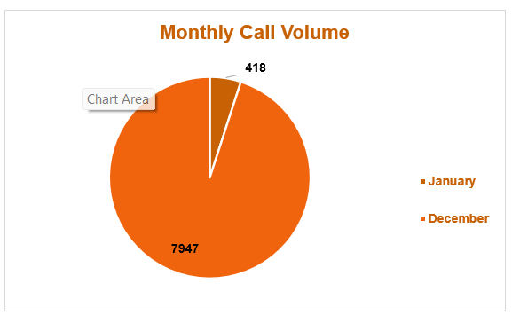

Question 6: What is the total operational cost for that month?

Solution:

Final Answer (if any):
The total operational cost was ₹99,146.57 including ₹93,786.16 in December and ₹5,360.41 in January
Approach (if any):
Used a Pivot Table to calculate the sum of astrologersEarnings for each month and determine the total opertional cost.
Charts & Tables (if any):
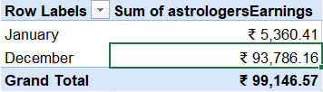

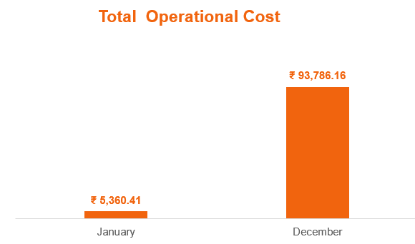

Question 7: What is the average number of calls handled per agent per day?

Solution:

Final Answer (if any):
The average number of calls handled per agent per day is 1.68 calls.

Approach (if any):
Calculatd the average using the formula: Total Calls ÷ (Total Unique Agents × Number of Days)
= 8,513 ÷ (149 × 34) = 1.68
calls per agent per day.

Charts & Tables (if any):
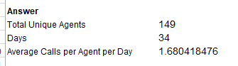

Question 8: How many repeat callers are there, and what percentage of total calls do they represent?

Solution:

Final Answer (if any):
There are 1,275 repeat callers , and % of repeat calls over all call is 56.63%.
Approach (if any):
Used a Pivot Table to count repeat and one-time caller then calculated the repeat caller percentage using the formula is (Repeat Calls ÷ Total Calls) × 100.
Charts & Tables (if any):

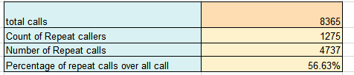

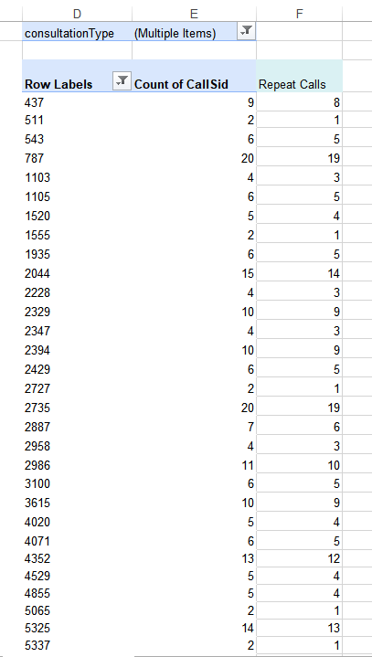

Question 9: What are the total sales generated by the call centre for each product category?

Solution:

Final Answer (if any):
The call centre generated total sales of ₹2,14,065.90 across all product categories:
- Call: ₹1,68,520.62
- Chat: ₹45,494.68
- Public Live Call: ₹50.60
- Complemenary: ₹0.00

Approach (if any):
Used a Pivot Table to calculate the sum of the amount for each product category.
Charts & Tables (if any):
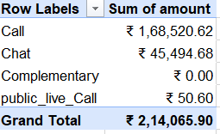
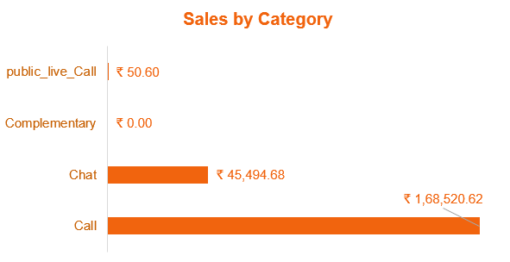

Question 10: How many calls were made for each user ID and guru ID?

Solution:

Final Answer (if any):
The number of calls was calculated separately for each User ID and Guru ID.
8365 calls were made from user ID and guru ID.

Approach (if any):
Used Pivot Tables to group the data by User ID and Guru ID and counted the ID records to detemine the number of calls made by each.

Charts & Tables (if any):

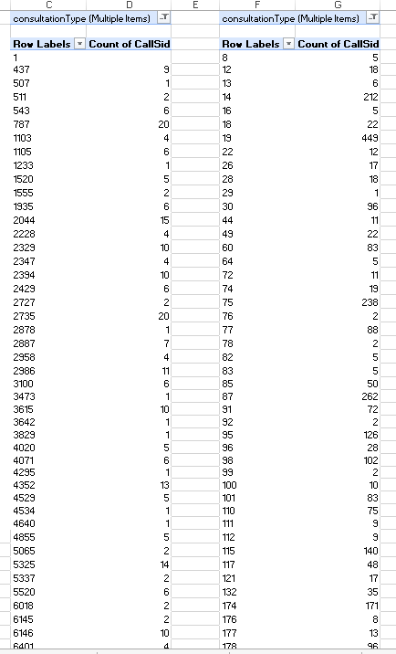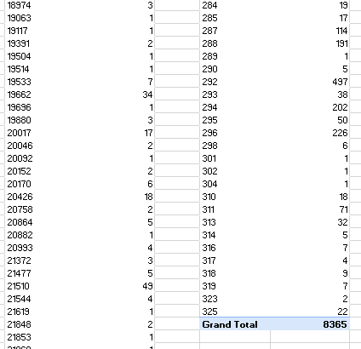
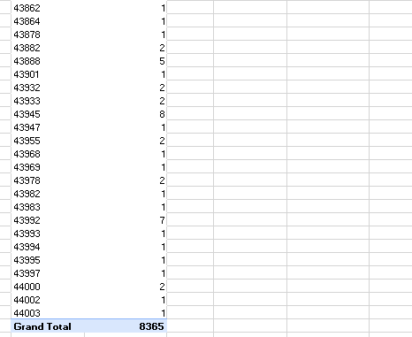

Question 11: What is the correlation between call duration and customer satisfaction?

Solution:

Final Answer (if any):
The correlation between call duration and customer satisfaction is -0.0002
almost no correlation between the two variables.
Approach (if any):
Used the CORREL formula to calculate the correlation between user call duration and customer rating.

Question 12: Which guru has the highest and lowest customer satisfaction scores?

Solution:

Final Answer (if any):
Astro Pujaa Rai and Tarot Mystical have the highest customer satisfaction score of 7.5, while Tarot Rittika has the lowest score of 0.

Approach (if any):
Used a Pivot Table to calculate the average customer rating for each guru

Charts & Tables (if any):
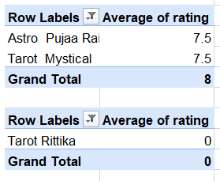

Question 13: What is the average customer satisfaction score by month?

Solution:

Final Answer (if any):
The average customer satisfaction score was 2.68 in January and 2.95 in December. The overall average satisfaction score is 2.93.

Approach (if any):
Used a Pivot Table to calculate the average custamer rating for each month.

Charts & Tables (if any):
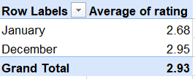

Question 14: How many categorical columns are there in the data? [Search about categorical and continuous data, and try to answer this question]

Solution:

Cleaned Data sheet, there are 14 categorical columns.

- chatStatus
- guruName
- guruName(updated)
- consultationType
- website
- refundStatus
- freeCall
- freeChat
- callChannel
- callIvrType
- callStatus
- astrologerCallStatus
- region
- userCallStatus

SUBJECTIVE QUESTIONS

Question 1: Should the investment be used to hire more agents, improve training programs, or upgrade call center technology?

Solution:

Approach:
The decision is based on agent ratings, call status, chat status, and call duration. I used PivotTables, counts, percentages, averages, and correlation to find whether the main problem is related to agent performance, workload, or technology..
Charts & Tables:

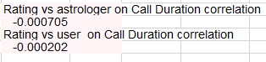

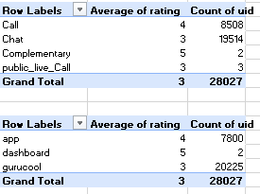
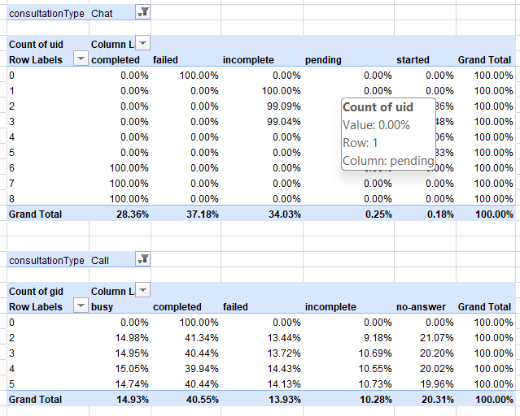
Insights:
- Chat has a major performance problem, with 37.18% failed and 34.03% incomplete chats. Together, 71.21% of chats are failed or incomplete.
- Calls perform better than chats, with 40.55% completed calls. However 20.31% are no-answer, 14.93% are busy, 13.93% failed, and 10.28% incomplete.
- The average rating for Chat is 3, while the average rating for Call is 4. This shows that chat performance needs improvement.
- Gurucool has an average rating of 3 with 20,225 users/interactions, which is much higher in volume than the other platforms. This makes it an important area to investigate.
- The correlation between rating and astrologer call duration is -0.000746, which is almost zero.
- The correlation between rating and user call duration is -0.000203, which is also almost zero.
- Therefore, call duration does not have a meaningful relationship with rating. The data does not show that simply increasing or decreasing call duration will improve ratings.
- The data also does not clearly prove that technology is the main reason for the failed/incomplete interactions.
Recommendations:
- Improve Training Highest Priority:
First, invest in training agents, especially in customer communication, problem-solving, and handling chats. The high percentage of failed and incomplete chats shows that agent performance needs attention.
- Upgrade Technology Second Priority:
Investigate the chat and call systems to find specific technical problems causing failed or incomplete interactions. Technology should be upgraded where the data shows an actual system problem.
- Hire More Agents Third Priority:
Do not hire more agents immediately. First check whether the existing agents are overloaded. Hire additional agents only if workload analysis shows that the current workforce cannot handle the demand.
- The investment should first be used to improve training programs. Technology impronements should be made after identifying specific technical problems, while hiring more agents should be considered only if workload analysis shows a capacity problem.

Question 2: What are the potential risks of each investment option (hiring, training, technology upgrades), and how can they be mitigated?

Name the chart/spreadsheet function you will use for solving the problem.

Solution:

Approach:
1> Hiring Workload & Guru Performance
Pivot Table: Workload by Hour
Chart: Workload line chart
Top 10 Guru Pivot and column chart to show workload is concentrated among a few gurus.
2> Training — Guru Ratings
Pivot Table: Average of Rating and Count of Rating by Guru.
It helps identify gurus with lower ratings and shows where training may be needed.
3> Technology Upgrade — Call Status
Pivot Table: Call Status by Hour
Chart: Call Status by Hour
It shows the percentage of calls that are completed, busy, failed, incomplete, etc., across different hours.

Charts & Tables:

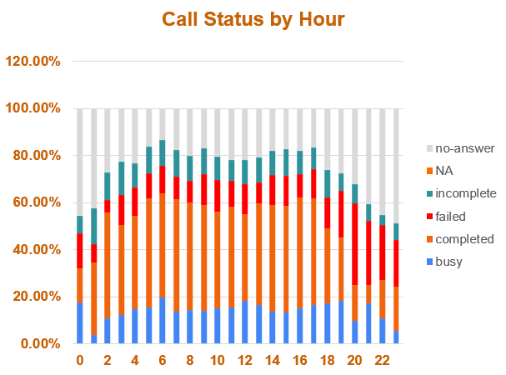
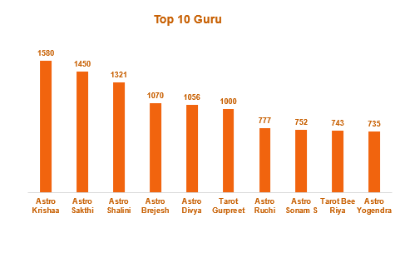
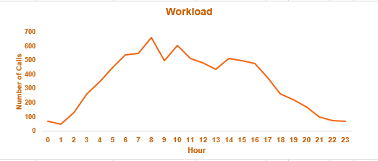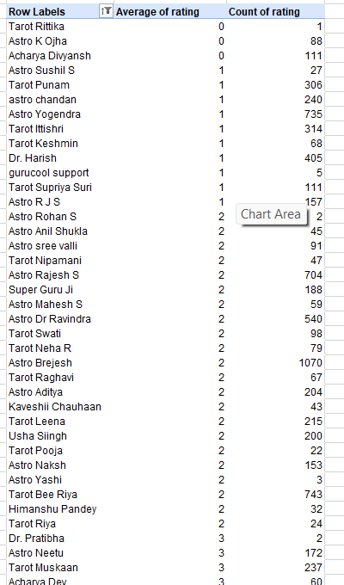
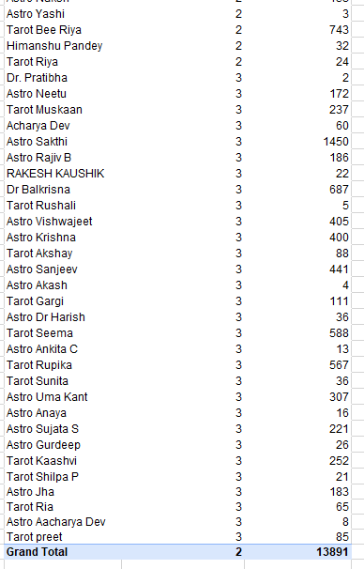
Insights:
Hiring: Workload changes a lot during the day.
The highest workload is 660 calls at Hour 8.
This shows that some gurus are handling much more work than others.
Hiring too many people can increase cost if demand is low.
Training : There are 65 gurus with an average rating of 3 or below.
Some gurus have low average ratings, which may indicate a need for training.
For example, Astro Yogendra has an average rating of 1 with 735 ratings.
This shows that some gurus may need improvement in service quality.
Training everyone would waste time and money.
Technology Upgrade: Only 41.26% of calls are completed.
20.67% are no-answer.
15.18% are busy.
12.43% are failed.
10.46% are incomplete.
So, a large portion of calls are not completed successfully.
A technology upgrade could help, but there is a risk of spending money without actually fixing the problem.

Recommendations:
- Hire more agents mainly for high-workload hours.
- Do not hire a large number of agents immediately.
- Use workload data to decide how many agents are actually needed
- Focus training on gurus with a high number of low ratings.
- Give specific training instead of training all gurus.
- Check their ratings again after training.
- Focus technology upgrades on reducing failed, busy and incomplete calls.
- Test the new technology on a small scale first.
- Compare call status before and after the upgrade.
- Upgrade fully only if the results improve.
Hiring: Add agents during high-workload hours instead of hiring too many people.
Training: Focus on gurus with more low ratings instead of training everyone.
Technology: First test a small technology upgrade and check whether failed, busy and incomplete calls decrease.

Question 3: How does AstroSage's call center performance compare to AstroGuru's average call volume, customer satisfaction, and agent performance?

Will you use any aggregation function or a visualization here to solve the problem?

Solution:

AstroGuru's data is not available in my dataset, so I cannot make a real comparison between AstroSage and AstroGuru.
if AstroGuru's data is provided later, I would compare both companies usig the same average and count calculations

Question 4: How can the call center improve its handling of peak call periods to ensure high customer satisfaction?

Mention the functionality you will use for giving the suggestions, will it be any aggregated function or a visualization?

Solution:

Approach:
Number of calls during different time slots and compared the workload during peak and non-peak periods. I used a pivot table with count to identif the busiest time slots. also used average rating to check whether customer satisfaction changes during busy periods
Charts & Tables:
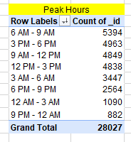
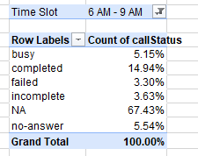
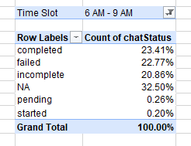
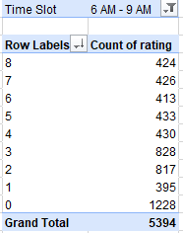
Insights:
The call center experiences higher call volumes during 6 Am to 9 am
During these periods, agents have to handle more customers at the same time, which can increase waiting time
Comparing the average rating by time slot helps identify whether peak workload is affecting customer satifaction. 1228 agents have got 0 rating at the peak hour while only 424 agents got 8 rating .

Recommendations:
- Increase agent availability during peak hours, especially 6 AM–9 AM
- Improve call routing during peak hours to distribute calls more evenly among agents
- rwducing unanswered calls should be a priority.
- Focus the investment on peak-hour staffing

Question 5: Based on historical data, what strategic initiatives should be prioritized to improve efficiency and customer satisfaction?

Solution:

Approach:
used PivotTables, Average, Count, and percentage analysis to compare customer ratings, consultatin types, website performance, call and chat status, and workload
Charts & Tables:
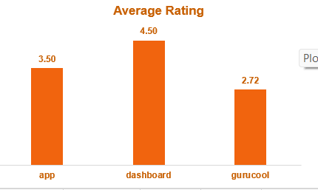
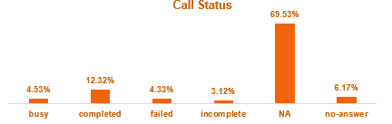
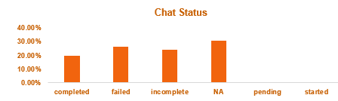
Insights:

- Dashboard has the highest average rating at around 4.5, while Gurucool has the lowest at around 2.72. This shows that Gurucool needs improvement in customer experience.
- Call status: 69.53% of records are marked NA, which represents chat/non-call interactions, so it should not be treated as unanswered calls.
- Among the actual call statuses, 12.32% are completed, 4.53% are busy, 4.33% are failed, 3.12% are incomplete, and 6.17% are no-answer.
- The presence of failed, incomplete, busy, and no-answer calls shows that some customer interactions are not being completed successfully.
- Peak periods should be managed carefully because higher workload can affect response quality.
Recommendations:
-Reduce failed and incomplete calls: Improve call routing and system reliability.
- Improve Gurucool performance: Investigate why its average rating is around 2.72 and focus on improving service quality.
- Strengthen peak-hour staffing: Keep more agents available during high-volume periods.
- Targeted agent training: Train agents who consistently receive lower ratings instead of giving the same training to everyone.

Question 6: What can be the key factors contributing to high customer satisfaction scores, and how can these be leveraged to improve overall performance?

What is the basis for the suggestions? And mention how you decided if the satisfaction score affects the ratings.

Solution:

Approach:
compared agent workload, average customer ratings, website ratings, and consultation-type ratings using PivotTables, COUNT, and AVERAGE. I used the results to identify factors associated with higher customer satisfaction.
Charts & Tables:

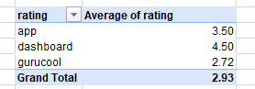
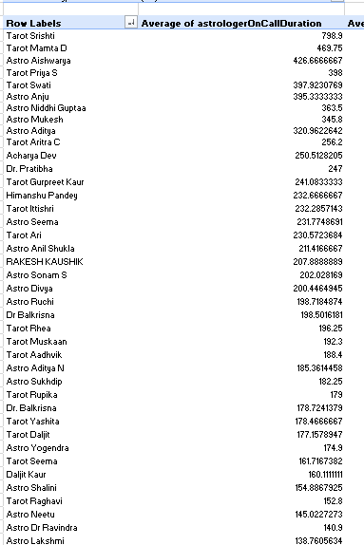
Insights

- Workload is unevenly distributed among agents. Some agents handle much more work than others.
- Dashboard has the highest average rating of 4.50, while Gurucool has the lowest average rating of 2.72.
- Complementary consultation has a high average rating, showing better customer satisfaction.
- Chat and public_live_Call have lower ratings and may need improvement.
- The difference in average ratings shows that the website/platform and consultation type can affect customer satisfaction.
Recommendations:

- Improve Gurucool and Chat services first because they have lower average ratings.
- Investigate the reasons for low ratings and improve the service process.
- Balance agent workload so a few agents are not handling a disproportionately large amount of work.
- Maintain the practices used by Dashboard and high-rated consultation types.
-Track average ratings after improvements to check whether customer satisfaction increases.
These recommendations are based on the Average Rating and Agent Workload PivotTables.
- Areas with lower average ratings were given higher priority because lower ratings indicate lower customer satisfaction.
- The rating comparison shows that Dashboard (4.50) performs better than App (3.50) and Gurucool (2.72).

Question 7: How should the call center balance the workload among agents to ensure optimal performance and avoid burnout?

Mention your approach and spreadsheet function for the answer.

Solution:

Approach:
Compared the average call duration per Guru with the overall average call duration of 121.31 using PivotTables and the AVERAGE function. Gurus with call duration above 121.31 were classified as High Workload, while those below 121.31 were classified as Low Workload.
Overall Average Call Duration is 121.30 with =AVERAGE(M7:M135) formula.
Charts & Tables:
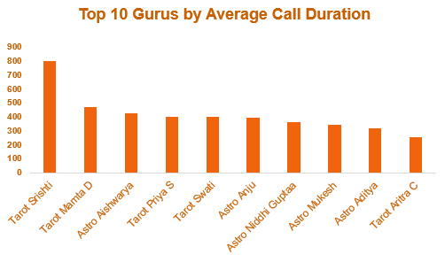
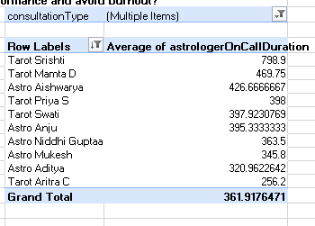
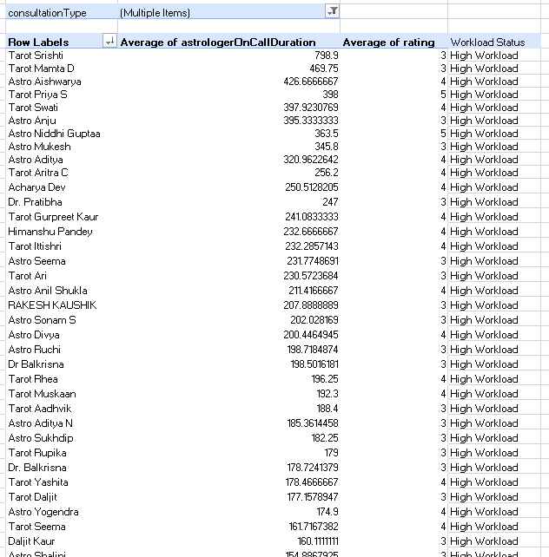
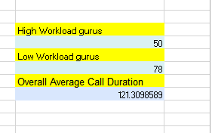
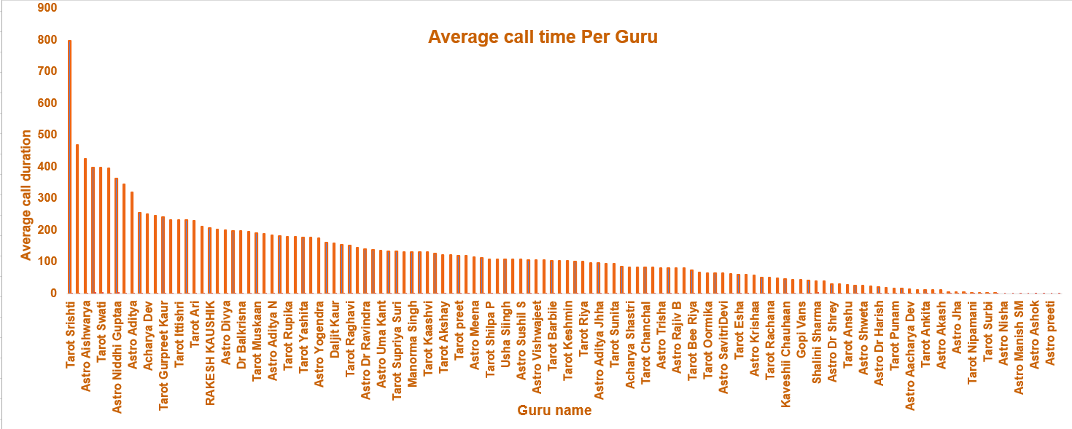
Insights:
The Workload is unevenly distributed among Gurus. 50 Gurus have an average call duration above the overall average of 121.31, indicating higher workload, while 78 Gurus are below the average. Tarot Srishti has the highest average call duration at 798.90, followed by Tarot Mamta D 469.75 and Astro Aishwarya 426.67.
Recommendations:
Redistribute workload from Gurus with average call duration above 121.31 to Gurus below this benchmark where possible. Prioritize the highest-workload Gurus, especially Tarot Srishti 798.90, Tarot Mamta D 469.75, and Astro Aishwarya 426.67. During peak periods, assign additional available agents to reduce excessive call duration. Regularly monitor Gurus whose average call duration remains significantly above 121.31 to prevent workload concentration and burnout.

Question 8: What new technologies or tools could be implemented to enhance call center operations and customer service?

Solution:

Approach:
The analysis uses the existing Peak Hours, Workload, and Call Status by Hour tables/charts to identify operational problems and match them with suitable technologies. The approach is to first identify periods of high call demand, then examine workload and call-status patterns, and finally recommend tools that can improve call routing, staffing, waiting time, and customer service.

Charts & Tables:
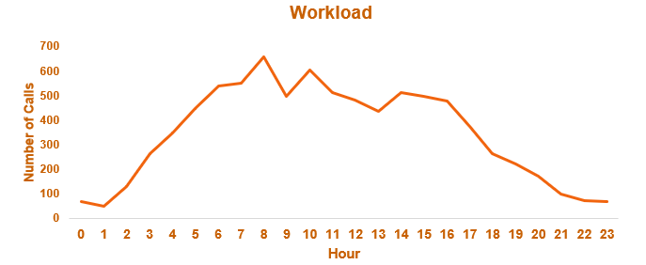
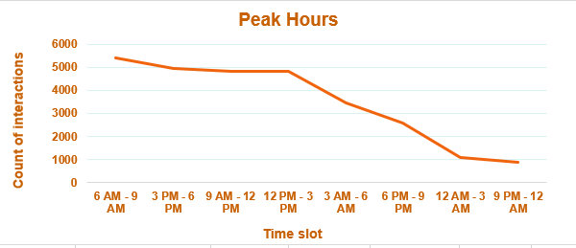
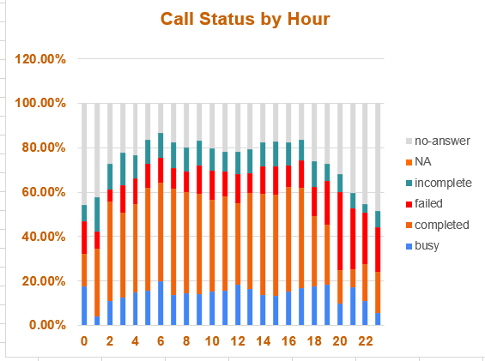
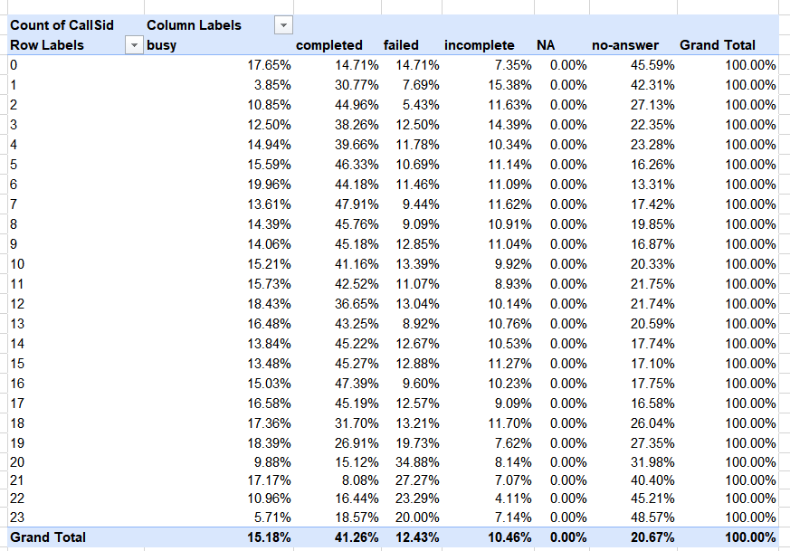
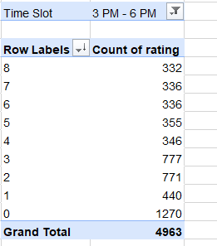
Insights:
- Peak hour pressure is significant: The highest interaction volume occurs during 6 AM–9 AM with 5,394 interactions, followed by 3 PM–6 PM with 4,963 interactions. This indicates that stafing and call-routing capacity need to be stronger during these periods.
- Workload varies considerably throughout the day: The Workload chart shows call volume increasing sharply during the morning and reaching its highest levels around 8 to 10 AM, indicating periods where agents may face higher workload.
- A large proportion of calls are not completed Only 41.26% of calls are completed, while 20.67% receive no answer, 12.43% fail and 10.46% are incomplete. This indicates an opportunity to improve call routing, queue management and agent availability.
- Technology should focus on peak-hour management: Since both call volume and workload increase substantially during certain hours, automated workforce scheduling and intelligent call distriution can help balance the workload among available agents.
Recommendations:
- Implement Automatic Call Distribution
to automatically route incoming calls to available agents based on their availability and workload.
Better distribution of calls, reduced agent overload and improved call completion rates.
- Implement Workforce Mangement Software
Use the Peak Hours and Workload analysis to schedule more agents during high-volume periods such as 6 AM–9 AM and 3 PM–6 PM.
- During peak periods, customers should be given the option to request a callback instead of waiting
- Implement an AI Chatbot
Use an AI chatbot to handle simple and repetitive customer queries before they reach human agents.
Reduce the number of routine queries handled by agents and allow agents to focus on more complex customer issues.
- Implement AI Call Analytics
Use AI to analyze call conversations and identify common customer problems, failed interactions and agent-performance issues.
Identify the root causes of poor customer experiences and improve agent performance.
- Prioritize implementation
- 1. Implement Automatic Call Distribution
- 2. Implement Automatic Call Distribution
- 3. request a callback
- 4. Implement AI Call Analytics

Question 9: What metrics should be included in the final dashboard to comprehensively view call center performance and guide investment decisions?

Solution:
The final dashboard should include total calls, total revenue, operational cost, average rating, call volume, calls per agent, call and chat status, workload, and guru performance. These metrics give a clear view of call center performance, customer experience, and areas where investment is needed.
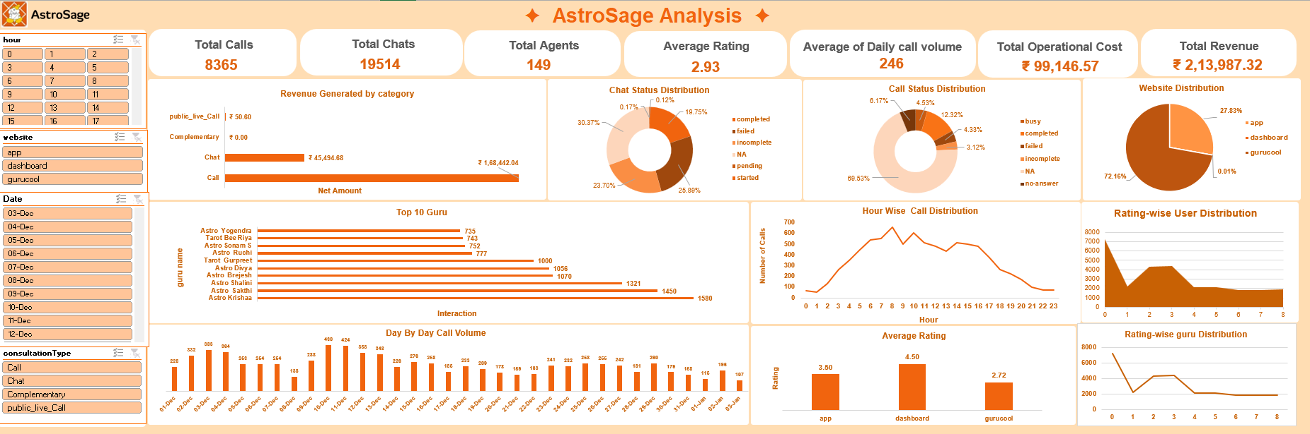

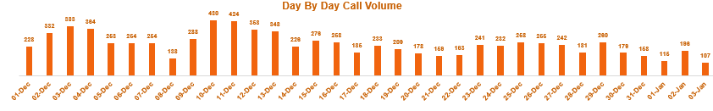
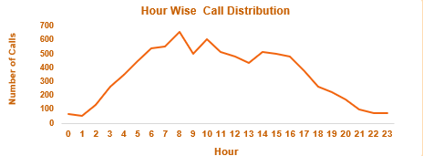
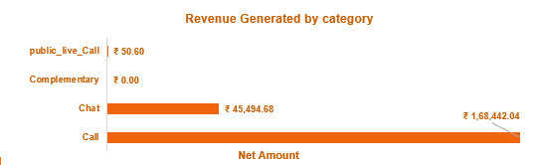
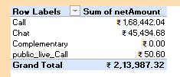
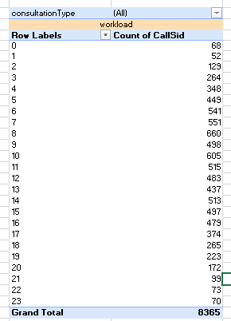
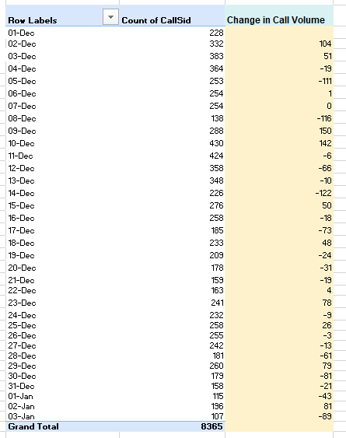

Question 10: How would you allocate a 1 crore rupee investment to optimize operational efficiency, enhance customer satisfaction, and boost profitability, and what analysis-based recommendations would you offer to support this?

[you have to give bullet pointers to answer this question]
Solution: Approach:
- Analyze platform-wise customer ratings, consultation-type ratings, peak-hour workload and rating-wise earnings to identify the areas having the greatest impact on customer satisfaction and profitability.
- Prioritize investment toward the areas with the largest identified performance gaps rather than distributing the ₹1 crore equally.
- Allocate the budget across agent training, technology upgrades, peak-hour staffing and quality monitoring.
- Track the impact using KPIs such as customer rating, completed-call rate, failed no-answer rate, workload and earnings.

Charts & Tables:
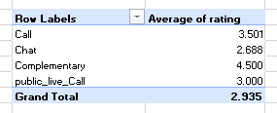
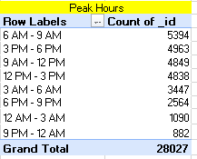
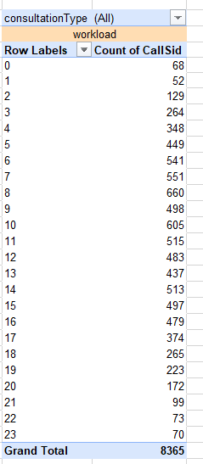

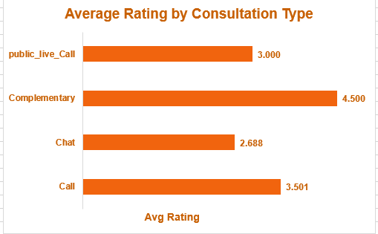

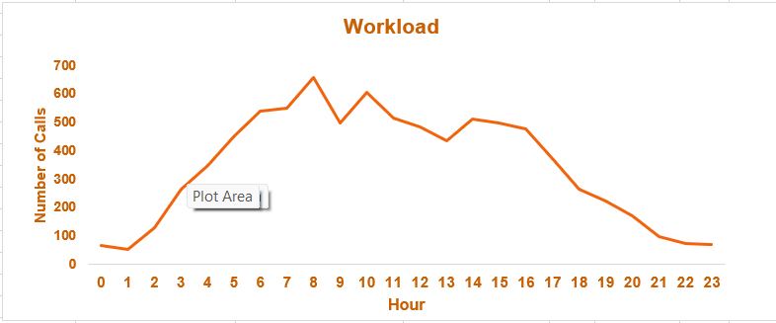
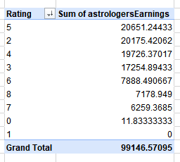

Insights:
- Gurucool has the lowest platform rating at 2.72, compared with 4.50 for Dashboard, indicating a significant platform-level customer experience gap.
- Chat has the lowest consultation-type rating at 2.69, while Call has a higher rating of 3.50. This suggests that improving the chat experiece should be a priority.
- 6 AM–9 AM has the highest interaction volume at 5,394, followed by 3 PM–6 PM with 4,963 interactions. These periods require better staffing and workload management.
- The call-status analysis shows only 41.26% completed calls, while 20.67% are no-answer, 12.43% failed and 10.46% incomplete. This indicates a clear opportunity to improve operational efficiency.
- Rating-wise earnings show that rating 5 generated ₹20,651.24, compared with ₹17,254.89 for rating 3, indicating that improving service quality can potentially support revenue performance. The relationship should be monitored further using rating-to-earnings correlation.
- Therefore, the investment should not be dominated by technology alone. The data shows customer-experience and agent-performance gaps that require substantal investment in training and quality improvement.

Recommendations:
1. ₹40 lakh – Agent Training
- Focus on communication, customer handling and problem-solving.
- Give extra training to low-rated agents/platforms.
- Track ratings and failed call rate.
2. ₹30 lakh – Technology Upgrade
- Implement AI chatbot, smart call routing and callback systems.
- Reduce failed, incomplete and no-answer calls.
- Track waiting time and completed call %.
3. ₹20 lakh – Peak-Hour Staffing
- Add agents during 6 AM–9 AM and 3 PM–6 PM, the highest-volume periods.
- Use flexible shifts instead of unnecessary full-time hiring.
- Track workload, calls per agent and waiting time.
4. ₹10 lakh – Customer Experience
- Monitor ratings and customer feedback by platform and consultation type.
- Conduct regular call and chat quality checks.
- Track complaints and quality scores.

